Vigenere Tableau

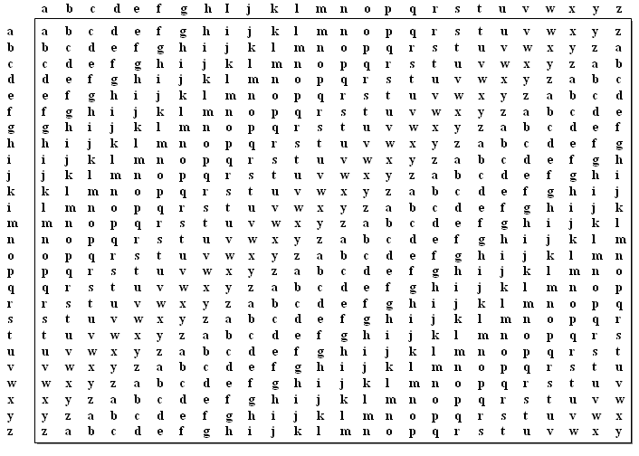

The horizontal represents the secret key.

The vertical represents the plaintext.

Choose a short key as a string (e.g. the, sec, org, …)

There are two methods to do cryptography (Enc & Dec):

1. **Using the Vigenere table.**

For Encryption, follow the steps:

1. Choose a secret key let (SEC).
2. Define the plaintext (SECURITY)
3. Repeat the key with the corresponding plaintext as:

Key: SECSECSE

Plaintext: SECURITY

1. From the table, meet the key letter with corresponding letter from the plaintext.

Example 1: using Vigenere Tableau method, encrypt the plaintext (SECURITY) using the key (SEC).

Key: S E C S E C S E

Plaintext: S E C U R I T Y

Sol: from the table, the intersection between the letters:

S and S = K

E and E = I

C and C = E

S and U = M

E and R = V

C and I = K

S and T = L

E and Y = C

So the ciphertext is: (KIEMVKLC).

For Decryption, follow the steps:

1. Repeat the secret key with the corresponding ciphertext.

Key: S E C S E C S E

ciphertext: K I E M V K L C

1. From the table, the key and the cipher are in the same column, find the corresponding plaintext. ناخذ حرف المفتاح, يكون الحرف المشفر في نفس عامود حرف المفتاح, نجد تقاطعهم مع النص الاصلي يعني نمشي الى اليسار.

Example 2: using Vigenere Tableau method, decrypt the ciphertext (KIEMVKLC) using the key (SEC).

Key: S E C S E C S E

ciphertext: K I E M V K L C

Sol: from the table, the intersection between the letters:

S and K = S

E and I = E

C and E = C

S and M = U

E and V = R

C and K = I

S and L = T

E and C = Y

So, the plaintext is: (SECURITY).

1. **Using the alphabetic table**

|  |  |  |  |  |  |  |  |  |  |  |  |  |  |  |  |  |  |  |  |  |  |  |  |  |  |
| --- | --- | --- | --- | --- | --- | --- | --- | --- | --- | --- | --- | --- | --- | --- | --- | --- | --- | --- | --- | --- | --- | --- | --- | --- | --- |
| **0** | **1** | **2** | **3** | **4** | **5** | **6** | **7** | **8** | **9** | **10** | **11** | **12** | **13** | **14** | **15** | **16** | **17** | **18** | **19** | **20** | **21** | **22** | **23** | **24** | **25** |
| **A** | **B** | **C** | **D** | **E** | **F** | **G** | **H** | **I** | **J** | **K** | **L** | **M** | **N** | **O** | **P** | **Q** | **R** | **S** | **T** | **U** | **V** | **W** | **X** | **Y** | **Z** |

C = E(k, p) = (p + k) mod 26

P = D(k, c) = (c – k) mod 26

For Encryption, follow the steps:

1. Choose a secret key let (SEC).
2. Define the plaintext (SECURITY)
3. Repeat the key with the corresponding plaintext as:

Key: SECSECSE

Plaintext: SECURITY

1. Use the alphabetic table, find the position of the two letters (K and P) and use the formula: C = E(k, p) = (p + k) mod 26.

Example 3: using Vigenere Tableau method with alphabetic table, encrypt the plaintext (SECURITY) using the key (SEC).

Key: S E C S E C S E

Plaintext: S E C U R I T Y

|  |  |  |  |  |  |  |  |  |  |  |  |  |  |  |  |  |  |  |  |  |  |  |  |  |  |
| --- | --- | --- | --- | --- | --- | --- | --- | --- | --- | --- | --- | --- | --- | --- | --- | --- | --- | --- | --- | --- | --- | --- | --- | --- | --- |
| **0** | **1** | **2** | **3** | **4** | **5** | **6** | **7** | **8** | **9** | **10** | **11** | **12** | **13** | **14** | **15** | **16** | **17** | **18** | **19** | **20** | **21** | **22** | **23** | **24** | **25** |
| **A** | **B** | **C** | **D** | **E** | **F** | **G** | **H** | **I** | **J** | **K** | **L** | **M** | **N** | **O** | **P** | **Q** | **R** | **S** | **T** | **U** | **V** | **W** | **X** | **Y** | **Z** |

Sol: from the alphabetic table and the formula:

S and S: (18 + 18) mod 26 = 36 mod 26 = 10 🡺 K

E and E: (4 + 4) mod 26 = 8 mod 26= 8 🡺 I

C and C: (2 + 2) mod 26 = 4 mod 26 = 4 🡺 E

S and U: (18 +20) mod 26 = 38 mod 26 =12 🡺 M

E and R: (4 + 17) mod 26 = 21 mod 26 =21 🡺 V

C and I: (2 + 8) mod 26 = 10 mod 26 = 10 🡺 K

S and T: (18 + 19) mod 26 = 37 mod 26 = 11 🡺 L

E and Y: (4 + 24) mod 26 = 28 mod 26 = 2 🡺 C

So the ciphertext is: (KIEMVKLC).

For Decryption, follow the steps:

1. Repeat the secret key with the corresponding ciphertext.

Key: S E C S E C S E

ciphertext: K I E M V K L C

1. Use the alphabetic table, find the position of the two letters (K and C) and use the formula: P = D(k, c) = (c – k) mod 26

Example 4: using Vigenere Tableau method, decrypt the ciphertext (KIEMVKLC) using the key (SEC).

Key: S E C S E C S E

ciphertext: K I E M V K L C

|  |  |  |  |  |  |  |  |  |  |  |  |  |  |  |  |  |  |  |  |  |  |  |  |  |  |
| --- | --- | --- | --- | --- | --- | --- | --- | --- | --- | --- | --- | --- | --- | --- | --- | --- | --- | --- | --- | --- | --- | --- | --- | --- | --- |
| **0** | **1** | **2** | **3** | **4** | **5** | **6** | **7** | **8** | **9** | **10** | **11** | **12** | **13** | **14** | **15** | **16** | **17** | **18** | **19** | **20** | **21** | **22** | **23** | **24** | **25** |
| **A** | **B** | **C** | **D** | **E** | **F** | **G** | **H** | **I** | **J** | **K** | **L** | **M** | **N** | **O** | **P** | **Q** | **R** | **S** | **T** | **U** | **V** | **W** | **X** | **Y** | **Z** |

Sol: from the alphabetic table and the formula:

S and K: (10 – 18) mod 26 = -8 mod 26 = 26-8 = 18 🡺 S

E and I: (8 – 4) mod 26 = 4 mod 26 = 4 🡺 E

C and E: (4 – 2) mod 26 = 2 mod 26 = 2 🡺 C

S and M: (12 – 18) mod 26 = -6 mod 26 = 26-6 = 20 🡺 U

E and V: (21- 4) mod 26 = 17 mod 26 = 17 🡺 R

C and K: (10 – 2) mod 26 = 8 mod 26 = 8 🡺 I

S and L: (11 – 18) mod 26 = -7 mod 26 =26-7 =19 🡺 T

E and C: (2 – 4) mod 26 = -2 mod 26 = 26-2 24 🡺 Y

So, the plaintext is: (SECURITY).

Try at class:

1. Encrypt the plaintext (CRYPTO) using the key (WHY) using alphabetic table.
2. Decrypt the plaintext (FEHNC) using the key (YES) using Vigenere table.

Try at home

1. Encrypt the plaintext (VIGENERE) using the key (SEC) using Vigenere table.
2. Decrypt the plaintext (VVQIMSYKTTZR) using the key (TEST) using alphabetic table.